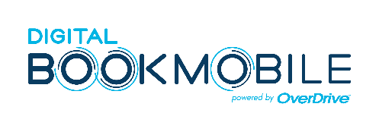
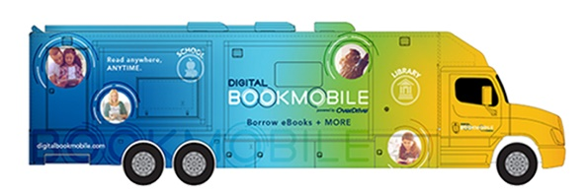
NEWS RELEASE
Contact:
Library Contact Name
Library Name
(555) 123-4567
email@library.com
(LIBRARY/SCHOOL NAME) To Host Digital Bookmobile National Tour Event on (DATE)
Free event highlights eBooks and audiobooks from the library -- anywhere, anytime
(City, State) – Date – The Digital Bookmobile National Tour is making a stop in (INSERT CITY, STATE IF NECESSARY). Spreading reading happiness to communities across the nation, this unique traveling exhibit is scheduled to visit (YOUR LIBRARY NAME) on (DATE/TIME) at (LOCATION). Visitors are invited to an interactive experience to learn about and try eBooks and audiobooks available from (LIBRARY NAME). Events are free for library lovers of all ages.
(LIBRARY NAME) staff and eReading experts will be available on the Digital Bookmobile to guide visitors through the easy process. Readers with a valid library card can borrow their favorite titles 24/7 by visiting http://(yourdigitallibraryurl).com or by downloading OverDrive's newest reading app, Libby.
“Quote from Library Director,” said NAME, DIRECTOR OF LIBRARY.
Readers at all levels of comfort and familiarity with eBooks are welcome at the Digital Bookmobile event on (DATE/TIME) at (LOCATION). Staff will facilitate one-on-one tutorials to help visitors borrow and read or listen to eBooks and audiobooks. Equipped with interactive workstations, touchscreen activities, devices to sample titles and more, the Digital Bookmobile has everything a reader needs to get started. Popular devices, including iPhone®, iPad®, Android™ phones and tablets, Chromebook™ and Kindle®, fill the Gadget Gallery for visitors to browse (LIBRARY NAME’s) digital service.
Come aboard to enhance your digital reading experience with tips and tricks from the experts, including how to sort and filter your searches, create bookmarks, highlight text, sync reading positions across mobile devices, and much more. Library card holders can take advantage of the featured services to borrow eBooks and audiobooks, (add video if library offers it) for free, 24/7 with no late fees on the library's website or by using the Libby app to read or listen instantly from virtually any smartphone, tablet or computer.
The Digital Bookmobile is powered by OverDrive, the industry-leading digital reading platform for more than 40,000 libraries & schools worldwide. To check out digital books and more, visit http://yourdigitallibraryURL.
About Your Library
(to be completed by or about library)
About the Digital Bookmobile
The 42-foot long Toterhome provides devices, internet connectivity and expert guidance to the local library's digital collection of eBooks and audiobooks. This traveling exhibit first launched in 2008 in Central Park, New York, and has since traveled more than 175,000 miles and welcomed 218,526 visitors at 869 events. Learn more at digitalbookmobile.com.

